

VistA Blood Establishment Computer Software (VBECS) Version 2.3.1

Administrator User Guide

June 2019

Department of Veterans Affairs

Enterprise Project Management Office

This page intentionally left blank.

Table of Contents

Introduction 3

VBECS Version Numbers 3

Related Manuals and Reference Materials 5

Customer Support 7

VBECS Maintenance Operations 9

Prerequisites 9

Outcome 10

Limitations and Restrictions 10

Additional Information 10

Log into VBECS Administrator 10

VBECS Administrator Operations 15

Common Controls 15

Edit System Interfaces 17

Assumptions 17

Limitations and Restrictions 17

Additional Information 17

Edit System Interfaces Steps Description 17

Edit Divisions 29

Assumptions 29

Limitations and Restrictions 29

Additional Information 29

Edit Divisions Steps Description 29

Edit Users 39

Assumptions 39

Limitations and Restrictions 39

Additional Information 39

Edit Users Steps Description 40

Index 49

Revision History 50

This page intentionally left blank.

# Introduction

VBECS is a Blood Bank application that facilitates ongoing compliance with Food and Drug Administration (FDA) standards for medical devices and enhances the VA’s ability to produce high-quality blood products and services to veterans. The system follows blood bank standards, standards of national accrediting agencies, FDA regulations, and VA policies.

The main purpose of the VistA Blood Establishment Computer Software (VBECS) is to automate the daily processing of blood inventory and patient transfusions in a hospital transfusion service.

 Unauthorized access or misuse of this system and/or its data is a federal crime. Use of all data, printed or electronic, must be in accordance with VA policy on security and privacy.

 Do not change the system!The U.S. Food and Drug Administration classifies this software as a medical device. Unauthorized modifications will render this device an adulterated medical device under Section 501 of the Medical Device Amendments to the Federal Food, Drug, and Cosmetic Act. Acquiring and implementing this software through the Freedom of Information Act require the implementer to assume total responsibility for the software and become a registered manufacturer of a medical device, subject to FDA regulations. Adding to or updating VBECS software without permission is prohibited.

Outlined text is used throughout this guide to highlight warnings, limitations, and cautions:

 Warnings, limitations, cautions

## VBECS Version Numbers

In previous VBECS patch releases, the user documentation referred to the VBECS version in a 4-digit format (e.g., 2.1.0.2 – where 2.1.0 represents the patch version and the last digit (2) is the patch build number).

The VBECS version (Figure 1) is now represented with only the first three digits (e.g., 2.1.0) and appears that way in all user documentation to simplify readability

The revision letter tracks database-only updates (e.g., blood product table updates, canned comments updates). The revision letter is normally a single alpha character (e.g., C), but can be two characters (e.g., AA, AB, AC) in the unlikely event that more than 25 database updates are made before a code change is implemented. The revision letter starts at A with each new code change and is incremented to B when the first database-only update is made. The revision letter is then updated by one character in the alphabet for every successive database-only update until a new code change is implemented, at which time the revision letter reverts back to A. The version submitted for system testing is revision A, but the version customers receive can be revision A, B or a higher revision letter.

Figure 1: Example of VBECS Administrator About Screen



DR 4992

The VBECS Administrator and VBECS applications, when started, will verify that the application code (binary build number) matches the SQL Server code (database build number) to ensure that application servers and SQL servers are patched and remain in sync with each other. In the rare event that they fall out of sync, the applications will present the following error message (Figure 2) and close until both the code and the database are in sync.

Figure 2: Example of System Error

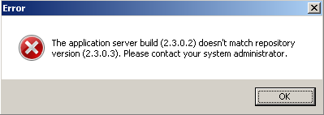

## Related Manuals and Reference Materials

* [*HL7 V2.3.1 Implementation Guide*](http://www.hl7.org/implement/standards/product_brief.cfm?product_id=141#ImpGuides)
* *CPRS-VBECS Interface (OR*3.0*212) Release Notes April 2009*
* *PIMS V. 5.3 Technical Manual*
* *Duplicate Record Merge: Patient Merge Technical Manual Version 7.3 April 1998 Revised December 2010*
* *Kernel Systems Manual Version 8.0, Chapter 1: Sign-On Security/User Interface, pp. 13–20*
* [*Manage Open Sessions and Files in Windows 2008 R2*](http://technet.microsoft.com/en-us/library/cc725689.aspx)
* *Health Product Support Release of Products and Patches Guide V2.3 Updated: February 2014*
* *VistA Blood Establishment Computer Software (VBECS) 2.3.1 User Guide*
* *VistA Blood Establishment Computer Software (VBECS) 2.3.1 Technical Manual-Security Guide*
* *VistA Blood Establishment Computer Software (VBECS) 2.3.1 Release Notes*
* Automated Instrument Setup Guides are located on the VDL (<https://www.va.gov/vdl/application.asp?appid=182>)
* *VistALink Version 1.5 Developer-System Manager Manual*, Chapter 6: Security Management, pp. 34–35
* [*Windows Server 2008R2 Security Guide*, Microsoft Corporation](http://technet.microsoft.com/en-us/library/gg236605.aspx)

This page intentionally left blank.

# Customer Support DR 4514

Contact your **Local** Information Resource Management (IRM) or Laboratory Automated Data Processing Application Coordinator (ADPAC) if you encounter VistA or CPRS connection problems and for training support **before** contacting the VA Service Desk (SD).

** Ensure local VistA Support contact information is available at all times. National Support will engage Enterprise Operations (EO) personnel as needed.**

**Problems with connectivity to VistA and CPRS may require personnel from EO with VBECS server administrator access and VistA IT support access.**

**If you experience an FDA reportable adverse event (patient death or serious injury) that VBECS may have caused or contributed to, contact the Enterprise Service Desk directly to enter a ticket for Blood Bank software support.** Task 605697

**If the problem remains unresolved after local VistA triage, contact the national Information Technology (IT) support service or request a region ticket to be reassigned to:**

**Enterprise VA Service Desk Contact**

See the **Customer Support** section of the *VBECS n.n.n Release Notes* (where *n.n.n* is the version of the release notes associated with this release).

Task 581023

**Enterprise VA Service Desk Alternate Contacts**

See the **Customer Support** section of the *VBECS n.n.n Release Notes* (where *n.n.n* is the version of the release notes associated with this release). Task 581023

This page intentionally left blank.

# VBECS Maintenance Operations

These maintenance operations are performed, using the VBECS Administrator software.

 Do not change the system!The U.S. Food and Drug Administration classifies this software as a medical device. Unauthorized modifications will render this device an adulterated medical device under Section 501 of the Medical Device Amendments to the Federal Food, Drug, and Cosmetic Act. Acquiring and implementing this software through the Freedom of Information Act require the implementer to assume total responsibility for the software and become a registered manufacturer of a medical device, subject to FDA regulations. Adding to or updating VBECS software without permission is prohibited.

 VistA data is treated as a master record for Divisions. VistA data and Active Directory are treated as a master record for Users. If a discrepancy is found between VBECS data and VistA or Active Directory, such records will be displayed as invalid and will require user intervention to correct.

 VBECS data is cross referenced with VistA data, so it is very important to make sure that the VBECS Administrator is connected to the correct VistA account. This is why before connecting to VistA, the user is presented with a VistA account confirmation message that contains all VistA account information (Figure 6 or Figure 7). If the VistA account is incorrect, the user must cancel the connection and specify the correct VistA account in VistALink External Interface settings. (see Maintain VistALink)

## Prerequisites

* VistALink is installed and running on the associated VistA system.
* The VistA Outbound logical links have been set up and started.
* The VBECS VistALink and VBECS HL7 windows services are installed and running on the application server.
* The user is defined in VistA, has a DUZ and connectivity to VistA can be established.
* The user has a valid Windows account and is defined as a member of the VBECS Administrator Active Directory (AD) domain group.
* The VBECS database is operational and up-to-date.
* If using an Automated Instrument interface in VBECS, the supporting Middleware system with applicable drivers should be set up and running.

## Outcome

* The VBECS Internal and External interfaces have been set up and started.
* VBECS users and divisions are defined and users can access/use VBECS per its divisional access.
* Changes to verified data are captured for inclusion in the Audit Trail Report.

## Limitations and Restrictions

* Only one instance of the VBECS Administrator can run at a time.
* Edit System Interfaces and Edit Divisions options cannot run when VBECS is operational. VBECS cannot run when a dialog in these options is operational.

## Additional Information

* None

## Log into VBECS Administrator

| **User Action** | **VBECS Administrator** |
| --- | --- |
| 1. Open a **Remote Desktop Connection**. | Displays the Remote Desktop Connection screen. |
| 1. Enter or select the name of the VBECS Application Server on the **Remote Desktop Connection** (Figure 3) screen and click **Connect**. | Displays Windows Security window for credentials. |
| 1. Select appropriate PIV, enter PIN, and click **OK** to enter the Remote Desktop Connection (Figure 4 and Figure 5). | Remote Desktop Connection establishes connection to target server.  Target server displays Warning screen. |
| 1. Click **OK** on the Security Warning screen.   If another message is displayed (about the last time the user logged in), click **OK**. | Displays VBECS server desktop with VBECS Admin Prod and VBECS Admin Test icons. |
| 1. Double-click the **VBECS Admin Prod** icon. | Opens VBECS Administrator. |
| 1. Select appropriate PIV, enter PIN if requested to connect to VistA (Figure 4, Figure 5 and Figure 6) when VBECS Administrator starts up or at the invocation of any option that uses VistALink when VistALink is not connected. | VistA account confirmation message is displayed. |
| 1. Verify that correct VistA account is displayed.  * If the VistA account is correct, enter the VistA Access and Verify Codes if requested (Figure 6) and click **Connect**. * If the VistA account is incorrect, click **Cancel**. Specify the correct VistA account in VistALink External Interface settings (see Maintain VistALink). Click **OK** to restart application. Go to Step 5. | Displays the main VBECS Administrator screen.  **NOTES**  BR_102.06 The user may skip logging into VistALink or continue and log on as needed.  BR_103.02 |

Figure 3: Remote Desktop Connection Options

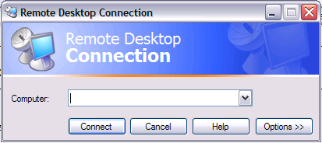

Figure 4: IAM – PIV Certificate

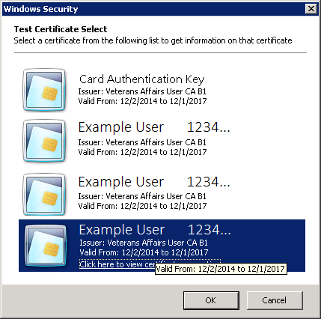

Figure 5: ActivClient Login

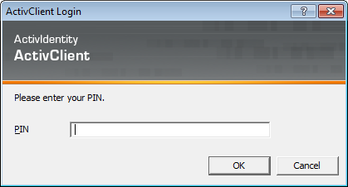

Figure 6: Example of VistA Logon with PIV

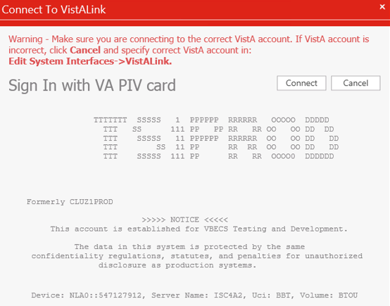

Figure 7: Example of VistA Logon with Access/Verify Codes

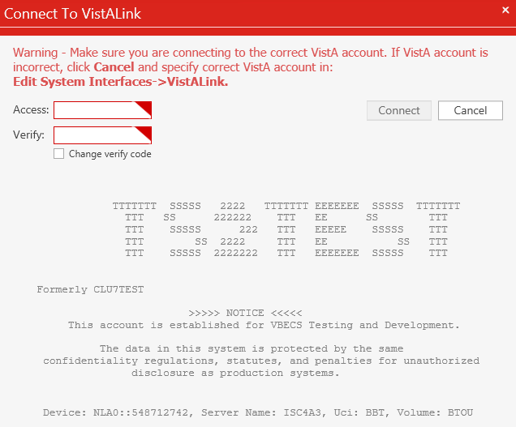

Figure 8: Example of VBECS Administrator

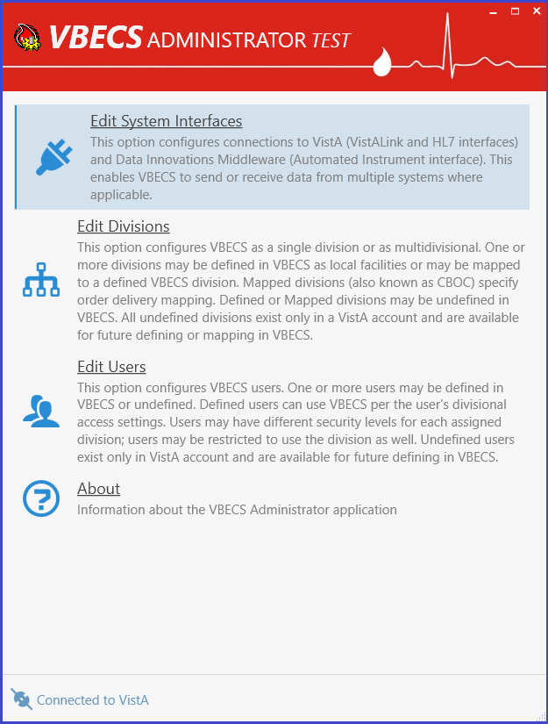

# VBECS Administrator Operations

## Common Controls

#### Navigation



There are three navigation buttons available at the top of the screen on all pages except the main screen (home page). These buttons act like regular web browser navigation buttons:

 The Home button takes the user to the main screen.

 The Back button takes the user back to the previous screen.

The Refresh button refreshes the current screen.



If there are any changes that have not been saved, a message box is displayed confirming whether the user would like to abandon their changes before performing a navigation action. If the user agrees to abandon changes, all the changes will be canceled and the user will be navigated.

#### Notification Popups

Notification messages pop up at the top-right corner of the main screen. There are four different types of notifications:  Success,  Warning,  Info and  Error. Success messages close automatically after five seconds. Also, all notifications are cleared by the Back, Refresh and Home buttons.



#### User Input Validation

If a user input error is detected in a particular field (for example if the port number is outside of the allowed range), an input error message popup is displayed next to the control and the control is surrounded by a red border.



#### Command Buttons

Configuration controls are controls that allow the user to change or configure data. Configuration controls are divided by sections. A section is represented by a tile and followed by one or more configuration controls. Command operations are performed per section. If the section content is changed, a command button appears and other sections get disabled to help the user focus on one task at a time. The text shown on the button describes the action that will be completed by clicking on it.



## Edit System Interfaces MUC_01

The VBECS Administrator sets up the parameters required for connection to VistA (VistALink and HL7 interfaces) and Data Innovations Middleware (Automated Instrument interface) enabling VBECS to send or receive data from multiple systems where applicable.

Interfaces are divided in two groups:

* Internal interfaces (marked with  label) are VBECS services that listen for incoming messages from external applications. Each internal interface corresponds with the windows service running on the VBECS application service:
  + VBECS VistALink Service corresponds with “VBECS Prod VistALink Listener”
  + VBECS HL7 Service corresponds with “VBECS Prod HL7 Listener”
* External interfaces (marked with  label) are all the other interfaces that VBECS communicates with.

### Assumptions

This guide supports previously installed and configured VBECS blood bank hospitals. If a new installation is necessary, file a Service Desk ticket (see the **Customer Support** section of *VBECS 2.3.1 Release Notes)*.

### Limitations and Restrictions

* It is recommended to restart the VBECS HL7 Service (i.e., “VBECS Prod HL7 Listener” windows service) and the VBECS VistALink Service (i.e., “VBECS Prod VistALink Listener” windows service) on the application server if its properties are changed. VBECS Administrator will also try to automatically restart services in certain scenarios and will notify the user if the attempt fails (usually due to insufficient user privileges). If you receive a service restart failure message, file a Service Desk ticket (see the **Customer Support** section of *VBECS 2.3.1 Release Notes*).
* This option is not allowed if someone is using VBECS at the same time.

### Additional Information

None

### Edit System Interfaces Steps Description

#### Maintain VBECS VistALink Service

Corresponds with “VBECS Prod/Test VistALink Listener” windows service and specifies which port number windows service is listening for incoming messages from the VistALink sender in VistA.

1. Log into VBECS Administrator.
2. Select the **Edit System Interfaces** menu option.



1. A new window populates with all available system interfaces and their status. Every interface that has connection properties shows its status in the right side. If the status is ERROR, it means that the interface is not functioning correctly and needs attention. Click the refresh button  to retest all interfaces.

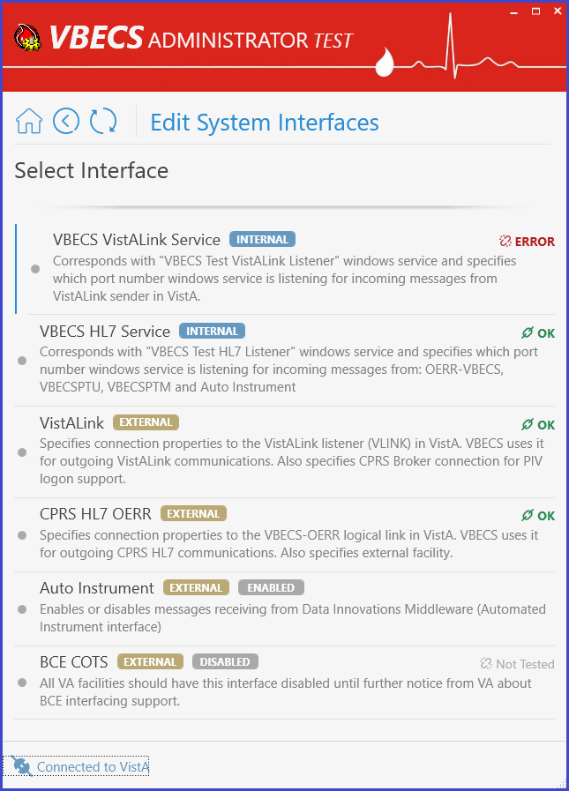

1. Select **VBECS VistALink Service**. A new window populates. The window contains detailed descriptions for all available configurations.



1. **To specify a new Port number**, enter the new value in the Port text box field under the *Local Connection* section and click **Assign new port number** button (displayed after the new value is entered).



Note: If a service restart failure notification failure pops up, file a Service Desk ticket (see the **Customer Support** section of *VBECS 2.3.1 Release Notes*). A restart failure usually happens if the user does not have administrative privileges to the application server.

#### Maintain VBECS HL7 Service

Corresponds with “VBECS Prod/Test HL7 Listener” windows service and specifies which port number the windows service is listening for incoming messages from: OERR-VBECS, VBECSPTU, VBECSPTM and Auto Instrument.

(Refer to the screen captures in the previous steps for a visual if needed.)

1. Log into VBECS Administrator.
2. Select the **Edit System Interfaces** menu option.
3. Select **VBECS HL7 Service**. A new window populates. The window contains detailed descriptions for all available configurations.



1. **To specify a new Port number**, enter the new value in the Port text box field under the *Local Connection* section and click **Assign new port number** button (displayed after the new value is entered).



Note: If a service restart failure notification failure pops up, file a Service Desk ticket (see the **Customer Support** section of *VBECS 2.3.1 Release Notes*). A restart failure usually happens if the user does not have administrative privileges to the application server.

1. **To specify a new E-mail for alerts**, enter the new value in the text box field and click **Assign new E-mail for alerts** button (displayed after the new value is entered).



1. **To specify a new Ack Timeout or Retransmit Attempts**, enter the new values in the text box fields under the *Data Transmission Controls (DTC)* section and click **Assign new DTC** button (displayed after new values are entered).



#### Maintain VistALink

Specifies connection properties to the VistALink listener (VLINK) in VistA. VBECS uses it for outgoing VistALink communications. It also specifies the CPRS Broker connection for PIV logon support.

(Refer to the screen captures in the previous steps for a visual if needed.)

1. Log into VBECS Administrator.
2. Select the **Edit System Interfaces** menu option.
3. Select **VistALink**. A new window populates. The window contains detailed descriptions for all available configurations.



1. Specify a new VistALink listener (VLINK) in VistA connection properties.

 VBECS data is cross referenced with VistA data, so it is very important to make sure that the VBECS Administrator is connected to the correct VistA account. This is why before connecting to VistA, the user is presented with a VistA account confirmation message that contains all VistA account information (Figure 6 or Figure 7). If the VistA account is incorrect, the user must cancel the connection and specify the correct VistA account in VistALink External Interface settings. (see Maintain VistALink)

1. Enter new IP or FQDN and Port number values under the *External Connection* section and click the **Test and Change External Connection** button (displayed after new values are entered).



Note: VBECS Administrator checks the connection to the VistALink listener first and if there is no connection found on the other end, an error message will be displayed.

* 1. **You selected a different VistA account warning** message is displayed. Click **OK** to confirm application restart.

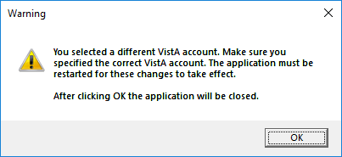

* 1. VBECS Administrator closes. The next time you start VBECS Administrator, it will be connected to the new VistALink listener (VLINK) in VistA.

1. **To specify new CPRS Broker connection properties**, enter new IP or FQDN and Port number values under the *Broker Connection* section and click the **Test and Change Broker Connection** button (displayed after new values are entered).

  
Notes:

* VBECS Administrator checks the connection to the CPRS Broker first and if there is no connection found on the other end, an error message will be displayed.
* Example of Collecting VistA Broker Values from a CPRS Shortcut.

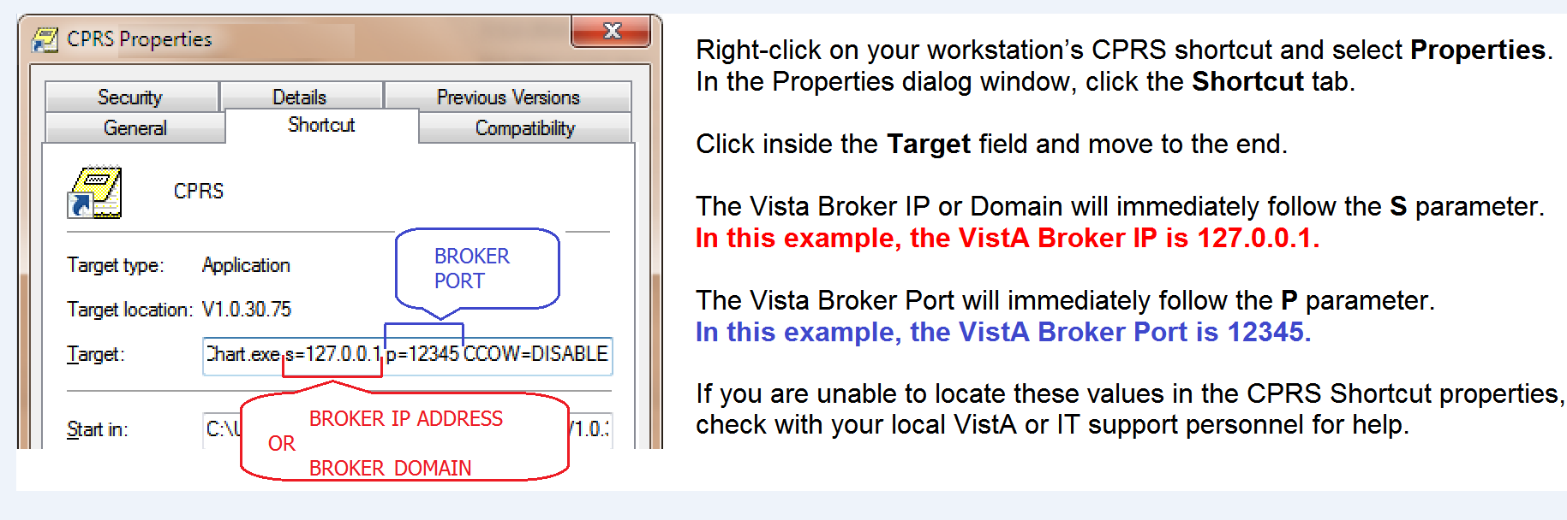

#### Maintain CPRS HL7 OERR

Specifies connection properties to the VBECS-OERR logical link in VistA. VBECS uses it for outgoing CPRS HL7 communications. It also specifies the external facility.

(Refer to the screen captures in the previous steps for a visual if needed.)

1. Log into VBECS Administrator.
2. Select the **Edit System Interfaces** menu option.
3. Select **CPRS HL7 OERR**. A new window populates. The window contains detailed descriptions for all available configurations.



1. **To specify new VBECS-OERR logical link in VistA connection properties**, enter new IP or FQDN and Port number values under the *External Connection* section and click the **Test and Change External Connection**button (displayed after new values are entered).

  
Note: VBECS Administrator checks the connection to the VBECS-OERR logical linkfirst and if there is no connection found on the other end, an error message will be displayed.

1. **To specify a new External Facility**, enter a new value in the text field and click the **Assign new facility** button (displayed after the new value is entered).



#### Maintain Auto Instrument

Enables or disables messages receiving from Data Innovations Middleware (Automated Instrument interface)

(Refer to the screen captures in the previous steps for a visual if needed.)

1. Log into VBECS Administrator.
2. Select the **Edit System Interfaces** menu option.
3. Select **Auto Instrument**. A new window populates.



1. **To disable messages receiving from Data Innovations Middleware**, turn the switch **Off** and click the **Deactivate Interface** button (displayed after the switch is changed).



1. **To enable messages receiving from Data Innovations Middleware**, turn the switch **On** and click **Activate Interface** button (displayed after the switch is changed).



#### Maintain BCE COTS

 All VA facilities should have the BCE COTS interface disabled until further notice from VA about BCE interfacing support.



## Edit Divisions MUC_02

The VBECS Administrator configures VBECS as a single division or as multidivisional. One or more divisions may be defined in VBECS as local facilities (marked with  label) or may be mapped (marked with  label) to a defined VBECS division. Mapped divisions (also known as CBOC) specify order delivery mapping: if blood is issued to a mapped division, all activities in VBECS associated with that order will be related to the mapped-to defined division.

Defined or Mapped divisions may be undefined in VBECS. All undefined divisions are marked with MBR_2.32  label; this means that they only exist in a VistA account and are available for future defining or mapping in VBECS.

### Assumptions

* The VistALink external interface (see Maintain VistALink) is configured and valid.
* VistA Logon has been executed successfully.

### Limitations and Restrictions

* This option is not allowed if someone is using VBECS at the same time.
* VBECS orders can only be mapped to divisions defined in VBECS.
* BR_9.09 When the division changes from full-service to transfusion-only or from transfusion-only to full-service, blood units and orders must be in a final state and eXM must be disabled.
* Divisions defined in VBECS must have at least one Level 6 (Administrator/Supervisor) user assigned in order to have access to the Supervisor menu options in VBECS.

 When orders mapping is changed, VBECS HL7 Service (i.e., “VBECS Prod HL7 Listener” windows service) should be restarted in order to accept these changes. If the user does not have the necessary permissions to do this, they will need to file a Service Desk ticket.

### Additional Information

 Changes in the mapping orders do not affect delivered orders. Orders delivered to a VBECS division must be completed, rejected, or canceled in that division. Resubmit orders after mapping is completed to send an order to another VBECS division.

### Edit Divisions Steps Description

#### Define a New VBECS Division

When access to VBECS has been granted in both Production and Test accounts, proceed to define the division in VBECS. (The steps are the same for Production and Test accounts, but each must be configured individually).

1. Acquire the division name and code.
2. Log into VBECS Administrator.
3. Select the **Edit Divisions** menu option. The option is only enabled if it is connected to VistALink.
4. Make sure the **Filter** drop-down menu is selected to show all or undefined divisions. You can further filter the list by typing the division’s name or code in “**Type here to search…**” search text box.



1. Locate the undefined division’s record from the list provided and click on it.
2. Once the undefined division is chosen, the user has the option to define the VistA division in VBECS as a local facility or specify orders mapping (also known as CBOC).
   1. **Define the VistA Division in VBECS as a Local Facility**
      1. Click “**Click here to Define**” to start defining the VistA division in VBECS as a local facility



* + 1. Select values for Associated FDA Registered Facility, Accession Area, Time Zone, Report Printer, Lock Timeout and specify if this is a full-service division or not by using the toggle button at the bottom.

Note: You can narrow down records by typing in the top text field of the drop-down boxes.

* + 1. After all values are specified, the **Define VistA Division in VBECS** button is displayed. Click this button.



* + 1. A new window populates the screen. Initially the division does not have any users assigned. Click the **Edit Users** link in the warning popup or manually navigate to the **Edit Users** screen to assign users to the division [see Define a New VBECS User and Maintain an Existing (Defined) VBECS User].



* 1. **Map Orders to Other Division (CBOC)**



* + 1. Click “**Click here to map orders to other division**” to specify the orders mapping for a selected VistA division (such divisions are also known as CBOC).
    2. Select the **VBCES Division** in the drop-down box to specify where orders should be mapped.
    3. After a division is selected, the**Assign orders mapping** button is displayed. Click on this button.



* + 1. A new window populates the screen. A mapped division does not have any configurations besides the **Click here to Un-map orders** link button to remove orders mapping.



#### Maintain existing (defined) VBECS Division

(Refer to the screen captures in the previous steps for a visual if needed.)

1. Log into VBECS Administrator.
2. Select the **Edit Divisions** menu option. This option is only enabled if the Administrator application is connected to VistALink.
3. Make sure the **Filter** drop-down menu is selected to show all or defined divisions. You can further filter the list by typing the division’s name or code in the “**Type here to search…**” search text box.
4. Locate the defined division’s record from the list provided and click on it. A new window populates with all available configurations for the division (use window scrolling if necessary).



* 1. **Mark the Division as Transfusion-Only or Full-Service:**

When the division changes from full-service to transfusion-only or from transfusion-only to full-service, blood units and orders must be in a final state and eXM must be disabled.

* + 1. If selected division is transfusion-only, the **Full Service Division** switch is in the **Off** position. Click on it to turn it **On** and click on the **Mark as Full Service** button (displayed after the switch is changed) to mark the division as full-service.



* + 1. If the selected division is full-service, the **Full Service Division** switch is in **On** position. Click on it to turn it **Off** and click on the **Mark as Transfusion Only** button (displayed after the switch is changed) to mark the division as transfusion-only.



* 1. **To change Associated FDA Registered Facility:** select a new facility from the **Associated FDA Registered Facility** drop-down box (narrow down records by typing in the top text field of the drop-down boxes) and click on the **Associate new facility** button (displayed after the new value is selected).



* 1. **Change Orders Mapping (CBOC)**.Current orders mapping (i.e., CBOC facilities) is listed under the *Orders Mapping (CBOC)* section.
     1. To cancel orders mapping, select the division orders mapping that should be canceled by clicking on the  button next to this divisions (CBOCs).



* + 1. To assign orders mapping from another division, select a new division in the **Orders Mapping (CBOC)** drop-down box (narrow down records by typing division name or code in the top text field of the drop-down boxes) and click the  button next to the drop-down box.



Note: You can repeat this step to select multiple divisions. Newly selected divisions are displayed in the list under the drop-down box (meaning these division are pre-selected but changes are not applied yet; see the next step to apply the changes).



* + 1. To apply the change, click on the **Assign new orders mapping** button (displayed after at least one division is added or removed).



* 1. **To change Accession Area:** select a new accession area in the **Accession Area** drop-down box and click on the **Assign new accession area** button (displayed after the new value is selected).



* 1. **To change Lock Timeout:** select a new lock timeout in the **Lock Timeout** drop-down box and click on the **Assign new lock timeout** button (displayed after the new value is selected).



* 1. **To change Label Printing:** specify new IP or FQDN and Port number values under the *Label Printing* section. The user can also enable or disable label printing by using the toggle button on the right. Click on the **Assign new label printing** button (displayed after new values are entered) to apply the change.



* 1. **To change Report Printer:** select a new report printer from the **Report Printer** drop-down box and click on the **Assign new report printer** button (displayed after the new value is selected).



* 1. **To change Time Zone:** select a new time zone from the **Time Zone** drop-down box, specify if day light savings time should be observed and click on the **Assign new time settings** button (displayed after new values are selected).

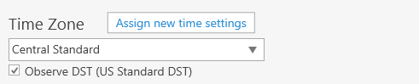

* 1. **Review division users:** A list of all current division users is located at the bottom of window. It is for information-only; use the **Edit Users** option to manage users (see Edit Users for more information).

#### Undefine VBECS Division

(Refer to the screen captures in the previous steps for a visual if needed.)

1. Log into VBECS Administrator.
2. Select the **Edit Divisions** menu option. This option is only enabled if the Administrator application is connected to VistALink.
3. Make sure the **Filter** drop-down menu is selected to show all, defined or mapped divisions. You can further filter the list by typing the division’s name or code in “**Type here to search…**” search text box.
4. Locate the defined or mapped division’s record from the list provided and click on it.
   1. If defined (i.e., local VBECS facility) the VistA division was chosen.
      1. Click the “**Click here to Undefine**” link button at the top portion of the screen.



* + 1. **Are you sure you would like to Undefine the current division?** confirmation window is displayed. If there are users currently assigned to this division, they will be displayed in the confirmation dialog for the information. Click **OK** to confirm.

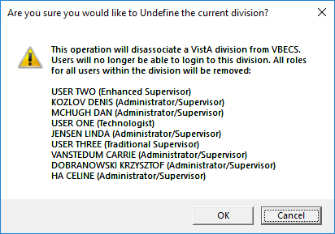

* + 1. The VistA division has been successfully undefined in VBECS. The screen returns back to the **Select VistA Division** list. The VistA division’s new state in the list is undefined.
  1. If mapped (i.e., CBOC), the VistA division was chosen.
     1. Click the **Click here to Un-map orders** link button at the top portion of the screen.



* + 1. **Are you sure you would like to Un-map orders from current division?** confirmation window is displayed. Click **OK** to confirm.

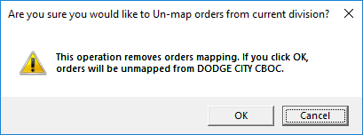

* + 1. The orders were successfully un-mapped from the VistA division. The screen returns back to the **Select VistA Division** list. The VistA division’s new state in the list is undefined.

#### Handle Invalid VBECS Divisions

If a previously defined VBECS division is not found in VistA, the corresponding record will be marked as invalid. This situation is highly unlikely; however, it could happen if it is connected to the wrong VistA environment for example. It is recommended to contact the Service Desk to resolve this type of situation.

## Edit Users MUC_03

The VBECS Administrator configures VBECS users. One or more users may be defined in VBECS (marked with  label) or may be undefined (marked with  label). Defined users can use VBECS per the user’s divisional access settings. Users may have different security levels for each assigned division; users may be restricted to use the division as well.

Undefined users only exist in the VistA account and Active Directory group and are available for future defining in VBECS.

### Assumptions

* The VistALink external interface (see Maintain VistALink) is configured and valid.
* Users have successfully logged in to VistA.
* Users have been assigned the appropriate VBECS Division in the NEW PERSON file (#200) DIVISION multiple.
* Users have been assigned the LRBLOODBANK and/or LRBLSUPER security key(s) in VistA.
* Users have been assigned the VBECS VISTALINK CONTEXT option as a secondary menu option in VistA.
* Users have been assigned to the correct Active Directory group [see Figure 1 (User’s Active Directory Group Name)]. Contact a local system administrator to add or remove VBECS users from your VBECS Active Directory groups.

### Limitations and Restrictions

* VBECS Administrator caches data collected from Active Directory at startup. In order to refresh it, the application must be restarted.

 Each VBECS user must have a unique Windows login ID. If a Windows login ID becomes inactive and is eligible for re-use in Active Directory, do not re-use it for VBECS: this may result in corrupted data in VBECS.

It is not recommended to change a user’s Windows login ID. If it does change, the current user record will be invalidated in VBECS Administrator. (DR3470)

### Additional Information

* MBR_3.15 Each defined VBECS user must have a unique DUZ.
* BR_19.04The VBECS User ID stored in VBECS is the user’s NT Logon ID.
* A VBECS Administrator/Supervisor can further configure VBECS users in VBECS, but an initial role must be defined for each VBECS user in VBECS Administrator. The option should be used primarily to define and undefine the user in VBECS.
* A user’s role may be changed while they are logged into VBECS; the change takes effect the next time the user logs into VBECS.
* The user name and e-mail in VBECS are silently synced with the user’s data from Active Directory if a discrepancy is detected.

### Edit Users Steps Description

#### Define a New VBECS User

When access to VBECS has been granted in both Production and Test accounts, proceed to define the user in VBECS. (These steps are the same for Production and Test accounts, but each must be configured individually).

1. Acquire the user’s full name and VA email address (Outlook/GAL).
2. Log into VBECS Administrator.
3. Select the **Edit Users** menu option. This option is only enabled if the Administrator application is connected to VistALink.



1. Make sure the **Filter** drop-down menu is selected to show all or undefined users. You can further filter the list by typing the user’s name or DUZ in “**Type here to search…**” search text box



1. Locate the new user’s record from the list provided and click on it.
2. Once the new user is chosen, expand the **Windows User** drop-down box to review the new user’s record. Ensure that the user’s name, e-mail and login ID are correct.



Note: If the **Windows User** drop-down box is initially blank and has a red border, it means that no automatic match was possible by the user name. In this case, manually select the windows user record from the drop-down list; you can narrow down records by typing the user name, e-mail or Windows ID at the top of the text field of the **Windows User** drop-down box.



1. Enter the initials of the user in the **Initials** box if not populated.
2. After all values are specified, the**Define VistA user in VBECS** button is displayed. Click on the button.



1. A new window populates the screen.
2. Initially, the user does not have any divisional access assigned. Under the *Divisional Access* section, locate the local VBECS Division; it should be defined.



1. From the drop-down menu to the right of divisional access, select the user’s level of access/user role for that local VBECS division an necessary. Note: You can assign divisional access only for defined divisions that are present in the user’s entry in the NEW PERSON file (#200) in VistA.



1. After all user’s roles are assigned, the**Change Divisional Access** button is displayed. Click on this button to assign the user’s divisional access.



1. The new user is now defined in VBECS and will have access to the program.

#### Maintain an Existing (Defined) VBECS User

(Refer to the screen captures in the previous steps for a visual if needed.)

1. Log into VBECS Administrator.
2. Select the **Edit Users** menu option. This option is only enabled if the Administrator application is connected to VistALink
3. Make sure the **Filter** drop-down menu is selected to show all or defined users. You can further filter the list by typing the user’s name or DUZ in “**Type here to search…**” search text box.
4. Locate the existing (defined) user’s record you would like to maintain and click on it.
5. Once the user is chosen, a new window populates the screen. On this window you can:
   1. **Map VBECS User to a Different Windows Account:**

Note: Be careful with this functionality, make sure the user is being mapped to the correct windows user.

* + 1. Expand the **Mapped Windows User** drop-down box and select a new windows account to map the current VBECS user to; you can narrow down records by typing the user name, e-mail or Windows ID at the top of the text field of the **Windows User** drop-down box.



* + 1. Once a new windows account for mapping is selected, the **Map VistA user to different Windows User** command button is displayed.



* + 1. Click on this button to map the current VistA user to a different Windows user.
  1. **Assign new user’s initials:**
     1. Enter the new user’s initials in the text box under the *Initials* section. After the new value is entered, the **Assign new user’s Initials** command button is displayed.



* + 1. Click on this button to assign the newly entered user’s initials. All user initials must be unique; if the initials you choose are already taken, you will be notified and must choose different initials.
  1. **Change user’s divisional access:**
     1. Under the *Divisional Access* section, locate all defined divisions where you would like to change the user’s access.
     2. Select different user’s roles from the drop-down boxes on the right side for each division as necessary. As soon as the first user’s role is changed, the **Change Divisional Access** button is displayed. Note: In order to remove the user’s access to the division, select the “-- **None** --” option for this division.



* + 1. After all user roles are assigned, click the **Change Divisional Access** button.

#### Undefine a VBECS User

(Refer to the screen captures in the previous steps for a visual if needed.)

1. Log into VBECS Administrator.
2. Select the **Edit Users** menu option. This option is only enabled if the Administrator application is connected to VistALink
3. Make sure the **Filter** drop-down menu is selected to show all or defined users. You can further filter the list by typing the user’s name or DUZ in the “**Type here to search…**” search text box.
4. Locate the existing (defined) user’s record you would like to undefine and click on it.
5. Once a user is chosen, a new window populates the screen. Click the “**Click here to Undefine**” link button at the top portion of the screen.



1. “This operation will remove all VBECS access for current VistA user” confirmation window is displayed. Click **OK** to confirm.



1. The VistA user has been successfully undefined in VBECS. The screen returns back to **Select VistA User** list.

#### Clear Invalid VBECS Users

If a previously defined VBECS user is not found in VistA or the Active Directory Group, the corresponding record will be marked as invalid. It is recommended to clear invalid records, because an invalid record might hold a DUZ or NT Logon ID. Invalid records are cleared together with all divisional roles.

If invalid records are found, the users’ list will be pre-filtered to invalid records when opened.

1. Log into VBECS Administrator.
2. Select the **Edit Users** menu option. This option is only enabled if the Administrator application is connected to VistALink
3. If invalid users are not found, the **Filter** drop-down menu will be pre-selected to show all and you will not see the invalid option if you expand it. You can stop here, since you do not have any invalid users.
4. If invalid users are found, the **Filter** drop-down menu will be pre-selected to show invalid users and an informational message will be displayed asking you to review the invalid users.



Every invalid record will have an explanation of what is wrong. For example, on the screen capture above, it says that User ONE is invalid because “**Previously Defined user does not exist in VistA**”.

1. To clear invalid users, there two options:
   1. Click on the invalid user record in the list and click **OK** on the confirmation message to clear it.



* 1. Or if you reviewed all invalid records and agree to clear them all at once, you can click the “**Click here to Clear all invalid users**” link button on the toast message and click **OK** on the confirmation message to clear all of them.



1. After all invalid records are cleared, the **Filter** drop-down menu will not present the invalid selection option.

# Index

C

Customer Support 7

I

Introduction 3

M

Maintenance Operations 9

R

Related Manuals and Reference Materials 5

V

**VA Service Desk** 7

# 

# Revision History

| **Date** | **Revision** | **Description** | **Author** |
| --- | --- | --- | --- |
| 1/7/19 | 1.0 | Initial Version.  (Task 871368)  Modified VistA Blood Establishment Computer Software (VBECS) 2.3.0 Admin User Guide, Version 2.0 to create VistA Blood Establishment Computer Software (VBECS) 2.3.1 Admin User Guide, Verizon 1.0.  Replaced most screenshots to reflect more information and increase clarity. Removed some screenshot descriptions, since the information is now presented directly on the screenshots. | BBM team |
| 6/10/19 | 2.0 | VBECS Administrator Operations section: Section revised to incorporate Health Product Support comments. (Task 898437)  Related Manuals and Reference Materials section: Revised name of Setup Guide entry and added VBECS 2.3.1 Release Notes.  How this Administrator User Guide is Organized section – Removed this section, and moved the warning box to the Introduction section.  VBECS Maintenance Operations section, Additional Information: Replaced the existing entry with “None”. | BBM team |

This is the last page of the *VistA Blood Establishment Computer Software (VBECS) 2.3.1 Administrator User Guide*.